**Door Jam – Formal Statement**

**Team Members:**

Aaron Rieck and Russell Newton

**Project Description:**

The project is a smart door opener that can be opened with the push of a button from the internet, preventing a user from ever being locked out. To open their door, the user must navigate to the door opener website and create an account. They will receive an email that their account is awaiting confirmation before it can used. After their account is confirmed by the administrator as the resident of the room they have indicated, it will be added to the database of registered accounts. The user can then log in to a cookie-authenticated page where they can press a button and open a door. The button sends an API request that runs a function on a Particle Photon which sends a signal to a TI Launchpad board. When the TI board receives the signal, it powers a stepper motor. This motor rotates a piece that turns the door handle to a predetermined amount of steps, holding the handle down for several seconds before moving back. This leaves ample time for a user on the other side of the door to push and enter. Unfortunately, the stepper motor we used does not produce enough torque to turn the door handle. A gear box or more powerful stepper motor could fix this problem.

**Hardware Used:**

TI Launchpad (MSP-EXP432P401R), Particle Photon, 28BYJ-48 stepper motor, ULN2003 stepper motor driver

**Software Used:**

C++, Node.js, MongoDB, HTML, CSS, BootStrap, Handlebars, Code Composer Studio, Particle Web IDE

**Creation Process:**

The first step in the process was creating a web server that could be securely logged into that sends the API request to the Particle Photon. After this, we tested executing functions on the Photon from the internet. Next, we added functionality to the web server such as a user database and confirmation emails. We also wrote the code to drive the stepper motor from the TI Launchpad. To do this, we created several helper methods and a helper class to make reading from and writing to the pin registers simple. We then worked on driving the TI board from the Photon. The problem we encountered was that the TI board was reading high from the Photon when it should not be. To fix this, we designed an emitter follower circuit using an NPN transistor to ground the input pin of the TI when the Photon is not outputting high, as well as buffering the Photon’s input into the TI. Originally, we also wanted to use a piezo speaker to play a tune from “Take On Me” by a-ha, but we experienced a similar problem where the Photon was reading high, and we weren’t able to fix it the same way, so we left it out of the final product. The 3D-printed parts are not very complicated and were printed without any problems.

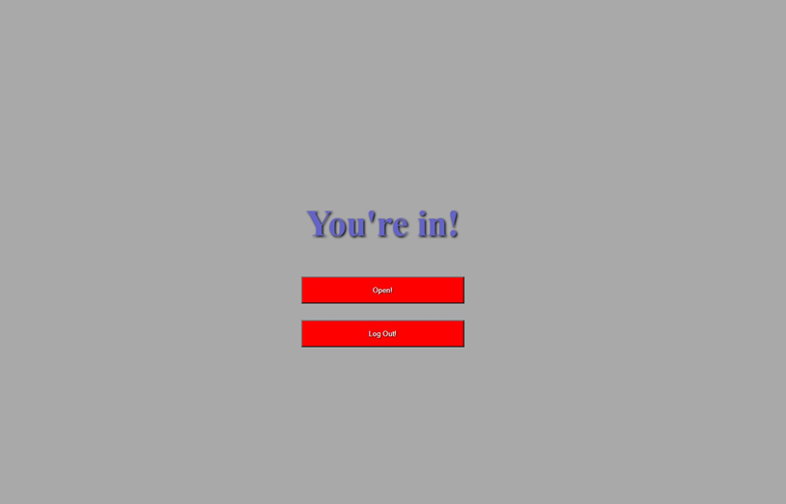

Screenshot of the page that lets a user open the door.

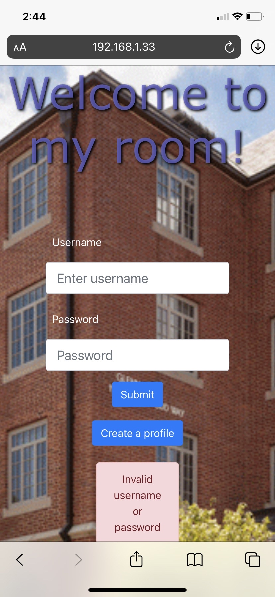

Screenshot of the login page, showing an invalid username or password dialogue.

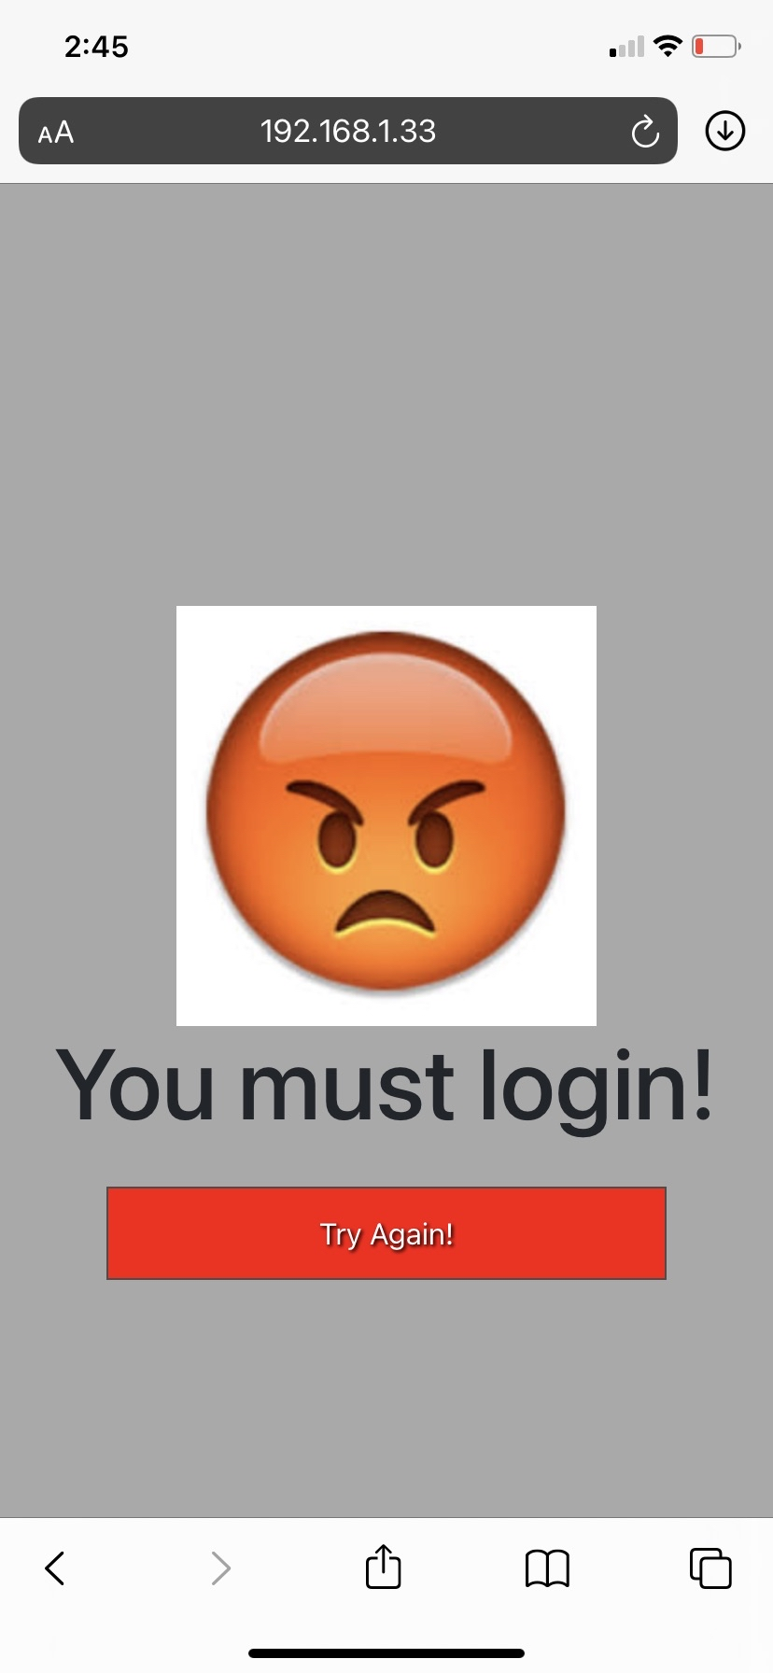

Screenshot of the page that is brought up if a user tries to bypass the login page.

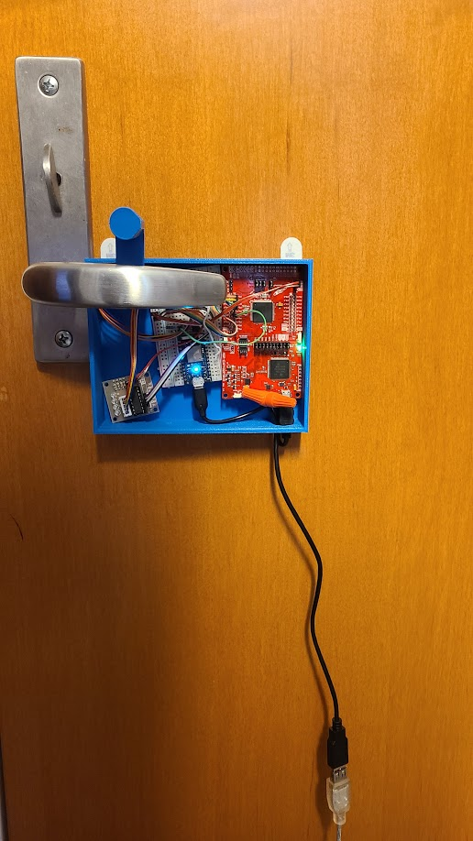

Photo of the hardware mounted onto the door. This stepper motor is not strong enough.

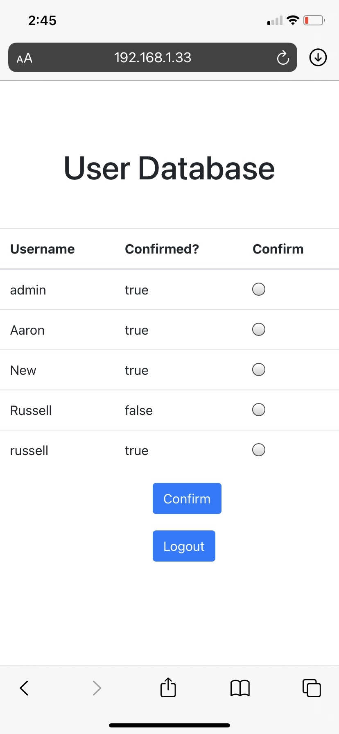

Screenshot of the user database on the admin page.